Class, Objects and Encapsulation

1. Write a constructor in the Car class given below that initializes the *brand* class field with the string “Ford”.

import java.util.Scanner;

class Car {

    String brand;

    //your constructor here

    public String getBrand() {

        return brand;

    }

    public static void main (String[] args) {

        Car ford = new Car ();

    }

}

Call the getBrand() method in the main method of the class  and store the value of the brand in a variable, and print the value.

**Answer:**

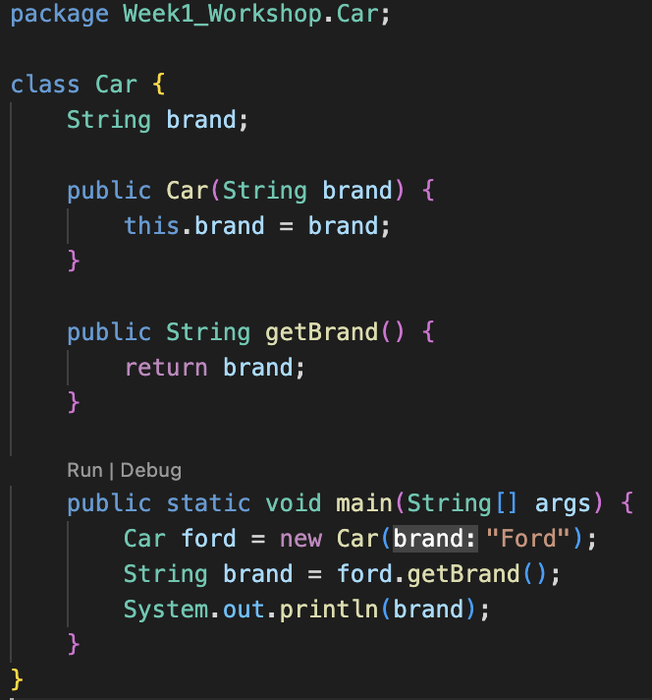

1. Create a class called Student with six data members (roll no, name, marks in English, math, science and total), a constructor that initializes the data members to the values passed to its parameters
2. Add a function to the Student class created above called calcTotal() that calculates the total of the marks obtained in the three subjects , and a function called display() that displays the details of the student. Create object of the class student and for each objects call the calcTotal() and display() functions

**Answer:**

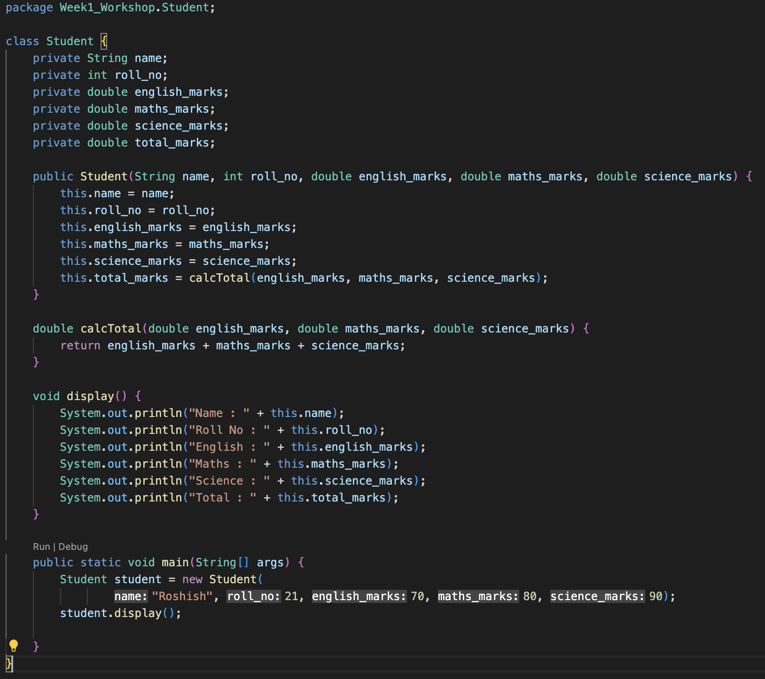

1. Answer the following giving suitable examples.

Can a default member of a class get accessed by

1. Same class

* Yes

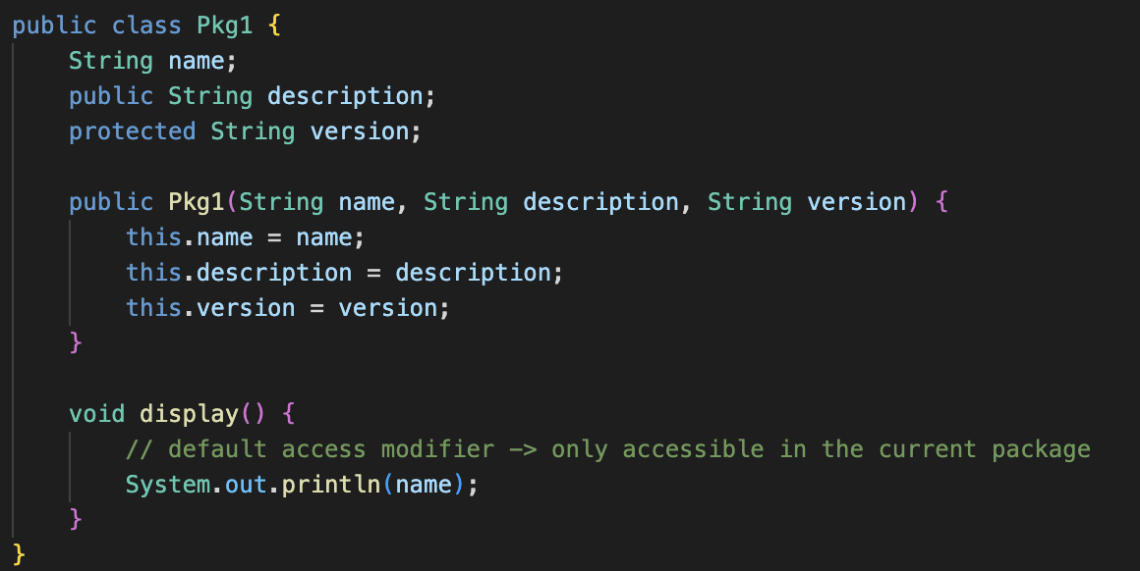

1. Other class in the same package

* Yes

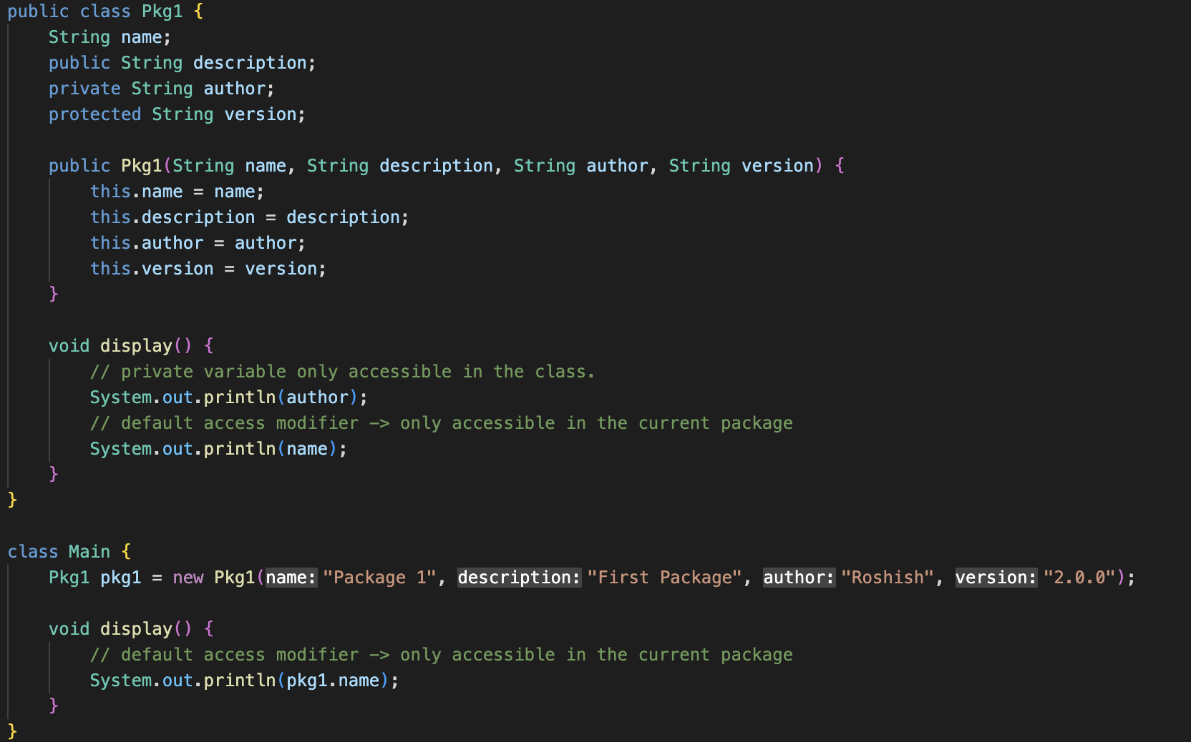

1. Class in any other package

* No

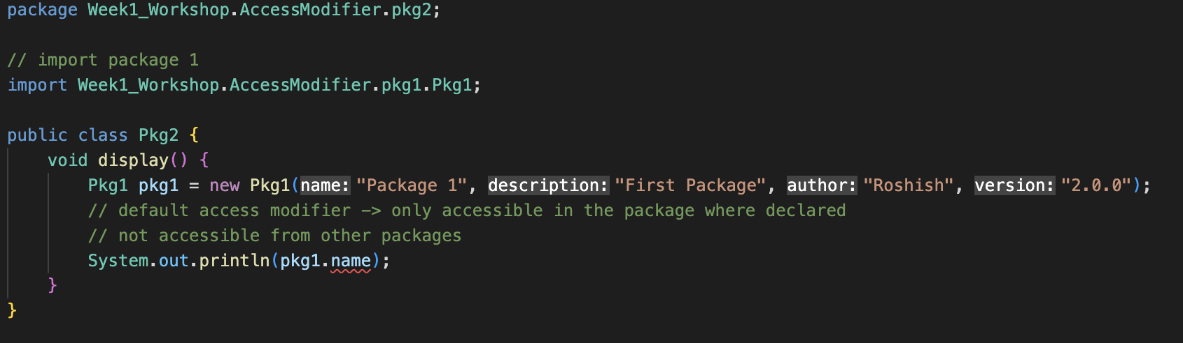

1. The code contains an error, attempt to compile and observe the resulting error.

class Data {

// private variable

private String name;

}

class Main {

public static void main(String[] main){

// create an object of Data

Data d = new Data ();

// access private variable and field from another class

d.name = "Program";

}

Then, fix whatever is wrong with the programs so that you are able to compile and run them.

Note : the class data and main both belong to the same package

**Answer:**

